*COS30018*

*Intelligent Systems*

*Task B.5*

Saynab Ismail

103063323@student.swin.edu.au

**Table of Contents**

Introduction……………………………………………………………….. 3

Multistep prediction problem function …………………....………....……3

Simple multivariate prediction function...……………..…………………..4

Conclution……….….……………………………………………….……..5

Issues……………………………………………………………………….5

Link to repository:https://github.com/SaynabIsmail/TaskB5

**Introduction**

This task involves creating functions to improve stock price predictions using deep learning. I attempted to develop a multivariate prediction function that uses different stock features—like opening and closing prices—to forecast future closing prices. Additionally, I attempted to implement a multistep prediction function to predict multiple future closing prices at once. This report will explain how these functions explain the functions and show the results.

**Multistep prediction problem function**

The code below implements a multi-step prediction function that predicts multiple future closing prices. This allows for forecasting a sequence of closing prices for multiple days into the future.

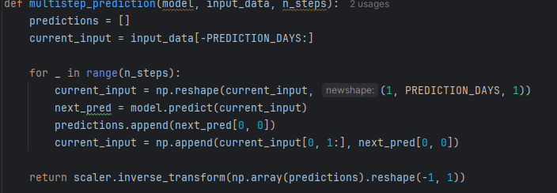

*Figure 1. Multistep prediction code*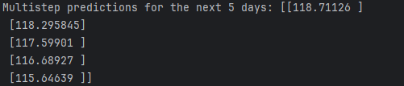

*Figure 2. Multistep prediction result*

**Simple multivariate prediction function**

This model is set up to take in various features (Open, High, Low, Close, Volume) to make predictions. This lets it use the right data to predict the closing price, dealing with the simple multivariate prediction problem.

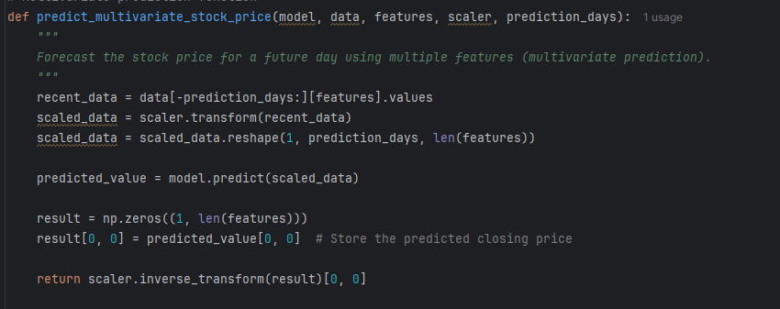

*Figure 4. Multivariate prediction code*

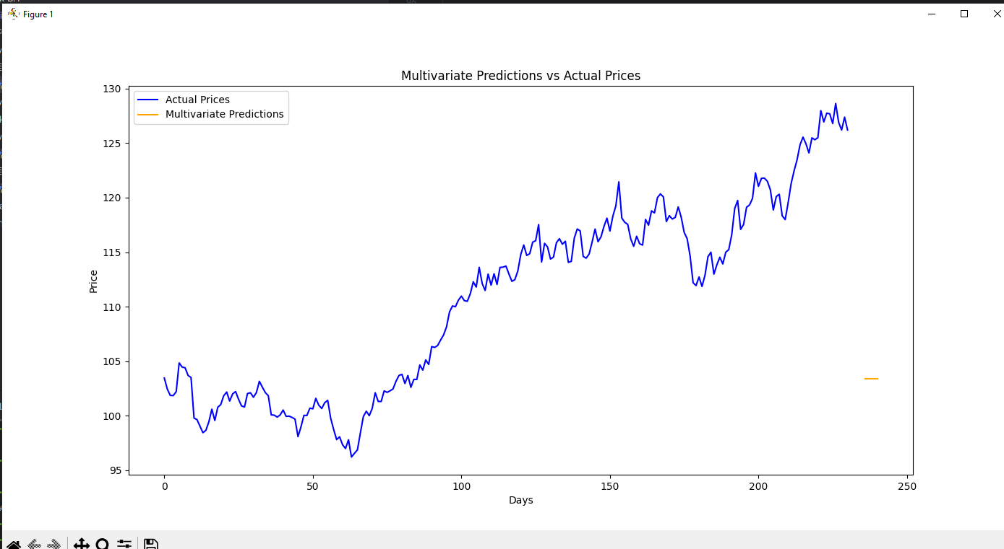

*Figure 5. Multivariate prediction result*

**Conclusion**

To conclude the purpose of this model is to use multiple input features related to the stock prices provided to predict several closing prices at once, meeting the multistep forecasting needs. The core logic for these predictions is organised into functions, making the model easy to understand and adaptable for future improvements.

**Issues:**

Could not get the combined functions to work